CPE22 – Embedded Systems
Implementation Strategies for complex embedded systems

Fundamentals of Design are | - Find out what the customer wants  - Think of way to give them what they want  - Prove what you have done by building and testing it  - Build a lot of the product to prove that it wasn’t an accident  - Use the product to solve the customer’s problem
Common life cycle models | - Waterfall model  - V cycle model  - Spiral model  - Rapid prototype
Waterfall Model | - The waterfall model represents a cycle specifically a series of steps appearing much like a waterfall. It is the model which is use to linear process development. It is a sequential design process, often used in software process development in which progress is seen as flowing steadily downwards through the phases of  - Conception, Initiation, Analysis, Design, Construction, Testing, Production/Implementation and Maintenance.  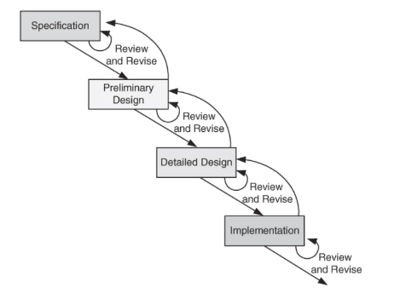  Figure 4.1 shows the water life cycle model  The steps are:  - Specification  - Preliminary design  - Design review  - Detailed design  - Design review  - Implementation  - Review  - The waterfall development model originates in the manufacturing and construction industries: highly structured physical environments in which after-the-fact changes are prohibitively costly, if not impossible.  - Since no formal software development methodologies existed at the time, this hardware-oriented model was simply adapted for software development.  Phases:  Requirement In this phase we gather necessary information which will use for development of any project . This phase defines what to do.  Design In design phase we then construct design to how to implement that requirements gathered into phase 1 .This phase define how to do  Coding Now base on design phase we then write actual code to implement algorithms. This code should be efficient.  Testing This phase use to test our coding part it checks all the validation like our code should work for each and every possibilities of input if any bug occur then we have to report that bug to design phase or development phase.  Maintenance In this phase we need keep updating information.  Process:  1 The implementation process contains software preparation and transition activities, such as the conception and creation of the maintenance plan;  2 The problem and modification analysis process, which is executed once the application has become the responsibility of the maintenance group. The maintenance programmer must analyze each request, confirm it (by reproducing the situation) and check its validity, investigate it and propose a solution, Document the request and the solution proposal, and, finally, obtain all the required authorizations to apply the modifications.  3 The process considering the implementation of the modification itself.  4 The process acceptance of the modification, by confirming the modified work with the individual who submitted the request in order to make sure the modification provided a solution.  5 The migration process is exceptional, and is not part of daily maintenance tasks. If the software must be ported to another platform without any change in functionality, this process will be used and a maintenance project team is likely to be assigned to this task.  6 Finally, the last maintenance process, also an event which does not occur on a daily basis, is the retirement of a piece of software.
V Model | - The V-Model is a term applied to a range of models, from a conceptual model designed to produce a simplified understanding of the complexity associated with systems development to detailed, rigorous development lifecycle models and project management models.  - Each test phase is identified with its matching development phase as shown in figure 4.2.  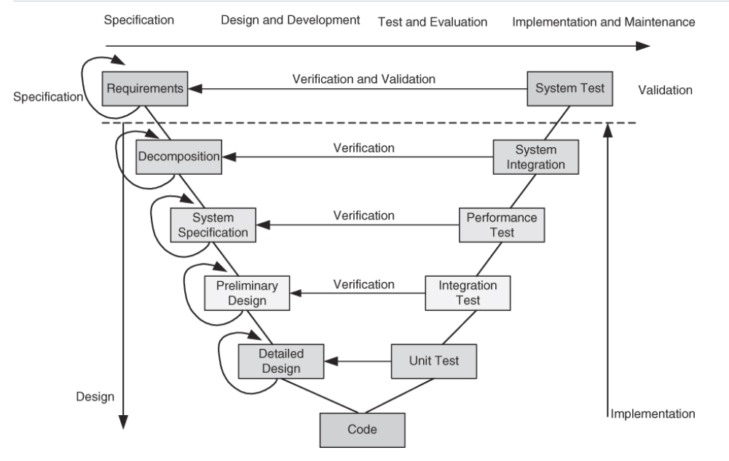  - The V-model is a graphical representation of the systems development lifecycle. It summarizes the main steps to be taken in conjunction with the corresponding deliverables within computerized system validation framework.  - The V represents the sequence of steps in a project life cycle development. It describes the activities to be performed and the results that have to be produced during product development.  - The left side of the "V" represents the decomposition of requirements, and creation of system specifications. The right side of the V represents integration of parts and their validation.  - Validation. The assurance that a product, service, or system meets the needs of the customer and other identified stakeholders. It often involves acceptance and suitability with external customers.  - Verification. The evaluation of whether or not a product, service, or system complies with a regulation, requirement, specification, or imposed condition. It is often an internal process.
The Spiral Model | - The spiral model is a software development process combining elements of both design and prototyping-in-stages, in an effort to combine advantages of top-down and bottom-up concepts.  - Also known as the spiral lifecycle model (or spiral development), it is a systems development method (SDM) used in information technology (IT).  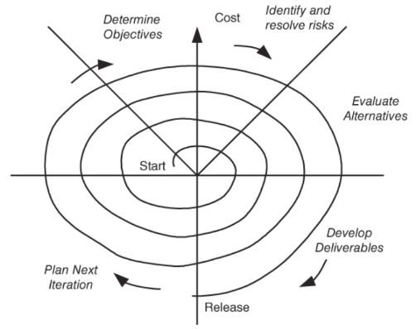  - This model of development combines the features of the prototyping and the waterfall model. The spiral model is intended for large, expensive and complicated projects. A simplified version of that model is presented in figure 4.3.  Steps in Spiral model life cycle are:  - Determine objective, alternatives, and constraints  - Identify and resolve risks.  - Evaluate alternatives.  - Develop deliverables verify that they are correct.  - Plan the next iteration.  - Commit to an approach for the next iteration.  - The spiral model combines the idea of iterative development (prototyping) with the systematic, controlled aspects of the waterfall model. It allows for incremental releases of the product, or incremental refinement through each time around the spiral.  - The spiral model also explicitly includes risk management within software development. Identifying major risks, both technical and managerial, and determining how to lessen the risk helps keep the software development process under control.  - The spiral model is based on continuous refinement of key products for requirements definition and analysis, system and software design, and implementation. At each iteration around the cycle, the products are extensions of an earlier product.  - This model uses many of the same phases as the waterfall model, in essentially the same order, separated by planning, risk assessment, and the building of prototypes and simulations
Rapid Prototype | - The Rapid prototyping model is intended to provide a rapid implementation of high-level portions of both the software and the hardware. The approach allows developers to construct working portion of hardware and software in incremental stages.  - Each stage through the cycle, one incorporates a little more of the intended functionality. The prototype is useful for both the designer and the customer. The prototype can be either evolutionary or throughway. It has the advantage of having a working system early in development process.
Problem Solving | 5 Steps to a successful design are:  - Requirement definition  - System specification  - Functional design  - Architectural design  - Prototyping  - The design process comprises of five distinct stages although it may vary for particular projects or design disciplines. This information may be useful when working with a designer to understand the processes involved.  - Before the project is started however, a vital question has to be asked: ―Why do you need a new identity, brochure or website etc?  - Identifying and formulating the requirement specification  - Requirements analysis in systems engineering and software engineering, encompasses those tasks that go into determining the needs or conditions to meet for a new or altered product, taking account of the possibly conflicting requirements of the various stakeholders, analyzing, documenting, validating and managing software or system requirements.  - Requirements analysis is critical to the success of a systems or software project. The requirements should be documented, actionable, measurable, testable, traceable, related to identified business needs or opportunities, and defined to a level of detail sufficient for system design.  - Conceptually, requirements analysis includes three types of activities  - Eliciting requirements: the task of identifying the various types of requirements from various sources including project documentation, business process documentation, and stakeholder interviews. This is sometimes also called requirements gathering.  - Analyzing requirements: determining whether the stated requirements are clear, complete, consistent and unambiguous, and resolving any apparent conflicts.  - Recording requirements: Requirements may be documented in various forms, usually including a summary list and may include natural-language documents, use cases, user stories, or process specifications.
Characterizing the System | - Requirements analysis can be a long and arduous process during which many delicate psychological skills are involved. New systems change the environment and relationships between people, so it is important to identify all the stakeholders, take into account all their needs and ensure they understand the implications of the new systems.  - Analysts can employ several techniques to elicit the requirements from the customer.  - Prototyping may be used to develop an example system that can be demonstrated to stakeholders. Where necessary, the analyst will employ a combination of these methods to establish the exact requirements of the stakeholders, so that a system that meets the business needs is produced.  - The System Design Specification (SDS) is a complete document that contains all of the information needed to develop the system. Systems design is the process of defining the architecture, components, modules, interfaces, and data for a system to satisfy specified requirements.  - Systems design could be seen as the application of systems theory to product development. There is some overlap with the disciplines of systems analysis, systems architecture and systems engineering.  - The requirement specifications provides a view from the outside of the system, design specification provides a view from the inside looking out as well. Design specification has 2 masters:  - It must specify the system‘s public interface from inside the system.  - It must specify how the requirements defined for and by the public interface are to be met by the initial functions of the system.  6 should be considered are:  - Geographical constraints  - Characterization of and constraints on interface signals  - User interface requirements  - Temporal constraints  - Electrical infrastructure consideration  - Safety and reliability  System specification versus system requirements  - Requirements give a description of something wanted or needed. They are a set of needed properties.  - Specification is a description of some entity that has or implements those properties.  - There is a distinct difference between requirements and specifications. A requirement is a condition needed by a user to solve a problem or achieve an objective.  - A specification is a document that specifies, in a complete, precise, verifiable manner, the requirements, design, behavior, or other characteristics of a system, and often, the procedures for determining whether these provisions have been satisfied.  - For example, a requirement for a car could be that the maximum speed to be at least 120mph. The specification for this requirement would include technical information about specific design aspects.  - Another term that is commonly seen in books and papers is requirements specification which is a document that specifies the requirements for a system or component. It includes functional requirements, performance requirements, interface requirements, design requirements, and development standards.  - A specification is a precise description of the system that meets stated requirements. A specification document should be:  - Complete  - Consistent  - Comprehensible  - Traceable to the requirement  - Unambiguous  - Modifiable  - Able to be written  Functional Design  - The functional design process maps the "what to do" of the Requirements Specification into the "how to do it" of the design specifications. During this stage, the overall structure of the product is defined from a functional viewpoint.  - The functional design describes the logical system flow, data organization, system inputs and outputs, processing rules, and operational characteristics of the product from the user's point of view.  - Functional Design is a paradigm used to simplify the design of hardware and software devices such as computer software and increasingly, 3D models.  - A functional design assures that each modular part of a device has only one responsibility and performs that responsibility with the minimum of side effects on other parts. Functionally designed modules tend to have low coupling.  Architectural Design  - The major objective of the Architectural design activity is the allocation or mapping of the different pieces of system functionality to the appropriate hardware and software blocks. Work is based on the detailed functional structure. The important constraints that must be considered include items as  - The geographical distribution.  - Physical and user interfaces  - System performance specifications.  - Timing constraints and dependability requirements  - Power consumption  - Legacy components and cost.  Hardware and software specification and design  - For the software design, the following must be analyzed and decided:  - Whether to use a real time kernel.  - Whether several functions can be combined in order to reduce the number of software tasks and if so, how?  - A priority for each task.  - An implementation technique for each inter-task relationship.  - The important criteria that we strive to optimize are:  - Implementation cost  - Development time and cost  - Performance and dependability constraints  - Power consumption  - Size  Functional model versus architectural model  - The functional model describes a system through a set of interacting functional elements. The design proceeds at a high level without initial bias toward any specific implementation.  - The functional models will interact using one of the following 3 types of relations:  The shared variable relation which defines a data exchange without temporal dependencies.  The synchronization relation which specifies temporal dependency.  The message transfer by port which implies a producer/consumer kind of relationship.  Architectural model  - The architectural model describes the physical architecture of the system based on real components such as microprocessor, arrayed logics, special purpose processors, analog and digital components, and the many interconnections between them.  Prototyping  - The prototype phase leads to an operational system prototype. A prototype implementation includes  - Detailed design  - Debugging  - Validation  - Testing  - A prototype is an early sample or model built to test a concept or process or to act as a thing to be replicated or learned from. It is a term used in a variety of contexts, including semantics, design, electronics, and software programming.  - A prototype is designed to test and trial a new design to enhance precision by system analysts and users. Prototyping serves to provide specifications for a real, working system rather than a theoretical one.

Techniques for Low-Power Operation

- Dynamic Power Reduction Techniques
- Static Power Reduction Techniques
- Software Techniques for Power Optimization
- Low-Power Design Techniques for IoT and Embedded Systems

Key Concepts in Power Consumption
- Power (P): The rate at which energy is used by a device.
  - Formula: P = V × I (Voltage × Current)
  - In digital systems, power consumption can be broken into:
    - Dynamic Power: Power consumed when a circuit is switching.
    - Static Power: Power consumed when the circuit is idle.
- Energy (E): The total power consumed over time.
  - Formula: E = P × t

Dynamic Power Reduction Techniques | - Dynamic power is proportional to the frequency of operation and the square of the voltage (P ∝ V² × f). Key techniques for dynamic power reduction include:  a. Voltage Scaling (Dynamic Voltage Scaling - DVS)  b. Clock Gating  c. Power Gating  d. Operand Gating  Voltage Scaling (Dynamic Voltage Scaling - DVS)  - Reducing the supply voltage significantly decreases dynamic power since power is proportional to voltage squared.  - Dynamic Voltage and Frequency Scaling (DVFS): Dynamically adjusts voltage and frequency based on performance requirements.  - Example: Mobile processors throttle down voltage and frequency during idle periods to save power.  Clock Gating  - Shuts off the clock signal to inactive parts of the circuit to reduce switching activity.  - Effective in reducing dynamic power, especially in large processors with many functional units.  - Example: Parts of a CPU (like the ALU) can be gated when not in use.  Power Gating  - Shuts off the power supply to inactive circuits, reducing both dynamic and static power.  - Power gating typically introduces some delay (wake-up time) when turning back on.  - Example: Used in sleep modes for microcontrollers and SoCs.  Operand Gating  - Reduce switching activity by limiting unnecessary signal transitions in certain blocks.  - Example: Arithmetic blocks can skip unnecessary operations when inputs are zero.
Static Power Reduction Techniques | - Static power consumption occurs even when no active switching is happening. It primarily results from leakage currents.  - Multi-Threshold CMOS (MTCMOS)  - Body Biasing  - Use of Sleep Transistors  Multi-Threshold CMOS (MTCMOS)  - Uses transistors with different threshold voltages in different parts of the circuit to balance performance and leakage.  - Low-threshold transistors are fast but leak more, while high-threshold transistors are slower but leak less.  Body Biasing  - Modifies the threshold voltage of transistors by applying a bias to the substrate.  - Forward body biasing: Reduces threshold voltage to increase speed at the cost of higher leakage.  - Reverse body biasing: Increases threshold voltage to reduce leakage, sacrificing speed.  Use of Sleep Transistors  - Switches off parts of the circuit during idle periods using transistors to cut the power supply.  - Minimizes leakage currents during low-power modes.
Software Techniques for Power Optimization | - In addition to hardware-based techniques, software plays a crucial role in reducing power consumption.  - Dynamic Power Management (DPM)  - Task Scheduling  - Adaptive Algorithms  Dynamic Power Management (DPM)  - System dynamically changes power states (active, idle, sleep, deep sleep) based on the workload.  - Example: CPUs enter idle states (C-states) when the operating system detects low usage.  Task Scheduling  - Efficient scheduling of tasks can reduce power consumption by reducing idle times or allowing deeper sleep modes.  - Example: A real-time operating system (RTOS) may schedule tasks in a way that maximizes low-power states.  Adaptive Algorithms  - Algorithms can be adapted to trade-off between performance and power.  - Example: Video codecs may adjust quality dynamically to lower processing requirements and save energy.
Low-Power Design Techniques for IoT and Embedded Systems | - Duty Cycling: Periodically turns the system on and off to save power.  - Energy Harvesting: Collects ambient energy (e.g., solar, vibration) to supplement or replace battery power.  - Low-Power Wireless Communication: Technologies like BLE (Bluetooth Low Energy) and Zigbee are designed for low-power communication.

Wireless Networked Embedded Systems
Characteristics of Deeply Embedded Networks | - Mobile ad hoc networks (MANETs) that are usually characterized by themes such as high overall node mobility, considerable power and resource consumption at the nodes and moderate network sizes have brought about quite a change to the traditional connection oriented, infrastructure-dominated telecommunications world.  - Wireless sensor networks have departed from this traditional viewpoint in an even more radical way as they are envisioned to be deeply embedded in very large quantity into the physical world.  - Myriads of smart devices ranging from naive identity tags and simple sensors broadcasting singular values such as temperature readings to much more sophisticated computing devices with multiple sensor/actor subsystems, advanced signal processing, data aggregation, extensive storage and diverse communication capabilities will be in constant interaction with each other, the surrounding ubiquitous digital infrastructure and human users.  - Wireless sensor networks are at one extreme of the design space, embracing such paradigm as immense scale, self-containment, self-organization, deep embedment and therefore also limited access of and to the devices involved.
Wireless Sensor Network Visions | - An early realization of "Anytime, Anywhere, Anyform“ information systems was proposed by Stemm and Katz in the context of the BARWAN project, where wireless overlay networks offer a hierarchical structure of room-size, building-size, and wide area data networks, to solve the problem of providing network connectivity to a large number of mobile users in an efficient and scalable way.  - The vision of “Smart Dust” put forward by Kahn in 1999 has sparked numerous activities in both theoretical and applied research of ultra-small networked embedded systems.  - Their vision foresaw a myriad of cubic millimeter, self-powered micro electro mechanical systems (MEMS) devices using optical links to communicate to a central system. Here the claim that only a varying percentage of the total devices deployed are con tributing to an actual network is key.  - Devices are thought to be so small and cheap that the extreme over-provisioning of the dust resources can actually become a reality. In the following this vision has led to the development of numerous commodity-off-the-shelf (COTS) dust platforms.  - Under the main prerequisite of wireless sensor networks, namely their stringent energy budget, the first “classical” approaches have focused on efficient, symmetrical ad hoc network configurations, meaning that the devices at both ends of a communication channel were essentially of the same architecture.  - These early prototypical “sensor nodes” are now constantly maturing and shift the focus from the fabrication of the single device as done by Hill and Rabaey toward the management of large, heterogeneous systems and architectures and the services embedded into these.  - In order to be able to scale to large networks consisting of the most heterogeneous clustered devices, mechanisms and services need to be tailored specifically for interoperability and the optimal management of the limited resources available on such nodes.  - The US based Committee on Networked Systems of Embedded Computers defined in their 2001 report “Embedded Everywhere- A research agenda for Networked Systems of Embedded Computers” the following general characteristics for such EmNets:  - Multiple interacting nodes  - Embedment into control systems without human intervention  - Purpose other than general computing and communication  - Natural or engineered contexts  Furthermore, the following special characteristics of EmNet requirements and their applicable technical solutions were specified:  - Energy-constrained nodes versus non-energy-constrained nodes  - Fixed topology versus flexible topology  - Safety-critical applications versus non-safety critical applications  - Highly engineered versus unconstrained, ad-hoc systems  Specifically, EmNets present the challenge of building large systems that are:  - Tightly coupled with the physical world  - Resource-constrained environment  - Persist for long periods of time  - Many interacting components  - Used and interacted with by non expert users
Sensor Network Applications | - Environmental Monitoring The Sensor Web is a new class of geographic information system (GIS) developed at NASA’s Jet Propulsion Laboratory consisting of a sensor network for environ mental monitoring and control using live, real-time streaming data from deployed systems.  - Sensor Webs have been field tested in many areas including the Huntington botanical gardens for botanical conditions including soil moisture and temperature, Antarctica to monitor micro climate conditions for extreme life detection, and, in cooperation with the University of Arizona, in the Avra Valley storage and recovery project for flood detection.  - Wildlife Habitat Monitoring In the Great Duck Island habitat monitoring deployment about 150 sensor nodes were distributed on an island to observe the nesting behavior of birds.  - Nodes are located both inside underground burrows to observe motion patterns of the birds and the micro-climate as well as outside as weather stations. Data is transmitted in streams over a multihop network to an access point where it is buffered and uploaded to a central database repository off the island using a satellite link.  - Building Management and Factory Automation Different applications ranging from security applications, structural health monitoring to building control and factory automation have been both proposed and built in prototype systems.  - Military Applications In a military vehicle tracking application wireless sensor network nodes are dropped from an unmanned aerial vehicle (UAV). The nodes form an autonomous network and collaboratively detect vehicle movements using built-in sensors. An occasional visit by the UAV collects and transports the resulting data to a command post behind enemy lines.
Design Space of Sensor Networks | - These commonly found assumptions could be interpreted as a de-facto definition of what a wireless sensor network is. In particular, sensor networks are typically considered large-scale (thousands of nodes, covering large geographical areas), wireless, ad hoc, multihop, unpartitioned networks of homogeneous, tiny, mostly immobile (after deployment) sensor nodes that would be randomly deployed in an area of interest.  - While there are definitely a number of applications that can be characterized in the above way, equally many applications deviate in various dimensions from the narrow definition mentioned above. In fact, the applications of sensor networks form an extensive design space with many dimensions.  - Deployment– one-time, incremental or as random activity  - Mobility– occasional or continuous performed by either selected or all nodes  - Cost, size, resources, and energy– very resource limited to unlimited  - Heterogeneity– a single type of node or diverse sets of differing properties and hierarchies.  - Communication modality– apart from radio frequency, optical, acoustic, inductive and capacitive coupled communication have been used  - Infrastructure– different applications exclude, permit or require the use of fixed infrastructure  - Network topology– single hop, star, multihop, mesh and/or multi-tier  - Coverage– sparse, dense or redundant  - Connectivity– continuous, occasional or sporadic  - Network size– ranging from tens of nodes to thousands  - Lifetime– few hours, several months to many years  - Other quality of service requirements– real-time constraints, tamper-resistance, unobtrusiveness, stealth and others
Design and Development of Wireless Networked Embedded Systems | - It was envisioned that sensor networks could be used for complex monitoring and control tasks, where the output of many sensors with different modalities would be processed, correlated, aggregated, or fused using advanced distributed signal processing functions.  - Also, it was anticipated that the resulting information would be used to control certain aspects of the sensor network, e.g. feedback loops for adaptive sampling or even to control distributed actuators.  - The measured physical signals typically display a low spatial and temporal variability, which makes them easy to handle. Also, distributed processing of sensor data in the network is often rather simple, e.g. averaging.  - In many cases, raw streams of sensor data are passed via a gateway to a back-end system as input for human users. Information obtained from sensors is rarely used to control sensing or actuation.  - Despite this low application complexity, the development of a running prototype with more than a few nodes is a surprisingly complex task that requires highly-skilled system programmers.  - In excess to the hardware and software involved, non-functional constraints have to be observed. In real-world experiments researchers have been struggling to achieve setups of more than a handful of nodes.  - Distributed simulation, is a valuable tool in the development process; it allows to study system-design alternatives in a controlled environment. The problem with simulation is that assumptions have to be made, simplifications have to take place, or models are simply wrong; this inevitably leads to a gap between reality and the simulated, virtual world.  - In addition, simulation results are known to not always be consistent across different scenarios or tool chains
Sensor Network Systems Design | - System design typically involves to partition the complete application into a number of sub-components both in hardware and in software, which together provide the required functionality of the system.  - Whenever possible, it is desirable to reuse existing components. The developer is then faced with the challenge of selecting appropriate components from potentially large set of available components.  - Selection of appropriate system components, e.g. the sensor node hardware, then requires the estimation of the minimum resource set necessary for correct, reliable and predictable operation.  - Typically, this issue is addressed today by over-provisioning additional resources and functionality in the design phase that is stripped in a later phase of prototype.  - Already a long-time issue in domains such as integrated circuit (IC) and embedded systems design, design-for-testability has not been an issue for sensor networks yet.  - Testing and debugging must already be considered during the design in order to provision necessary resources, e.g. memory, communication bandwidth, non-volatile storage for logs.  - Also, issues such as calibration and verification may have to be considered already during system design.  - The design space of sensor networks presented earlier indicated that, in general, there are no one-size-fits-all solutions for particular tasks. Rather, a variety of different solutions will be needed to cover significant portions of the design space.  - Hence, a large set of reusable components must be expected to be available in the future for the developer to select from, e.g. different sensor nodes with different amounts of resources.  - Every solution would have properties that are adapted to a certain region in the design space, e.g. a time synchronization service that supports mobility but provides low precision.  - It would be highly desirable to support the application developer in this often complex selection process with appropriate concepts and tools to narrow down the set of design alternatives.
Prototype Development– Programming and Debugging | - Once the application has been partitioned into functional components during the design phase, some existing components may be reusable without modification, other existing components may have to be modified, and some components may have to be developed from scratch.  - As far as software components are concerned, modifications and new developments require programming work.  - Given the required level of abstraction, the developer should be relieved as much as possible from programming individual sensor nodes at the system level, including distribution issues by providing appropriate high-level abstractions that allow the programmer to think in terms of the application.  - However, the use of abstractions often introduces performance and resource overheads, which typically is a major issue in sensor networks. Hence, a major challenge is to find programming abstractions which are appropriate both with respect to the developer skills and with respect to efficiency.
Sensor Network Deployment and Testing | - Leading to meaningful results, sensor networks need to be deployed in an actual physical environment where sensor/actor interaction can take place at realistic scale and the environment for wireless communication is matching both in dimensions and properties.  - Moving on from programming and debugging of the single nodes to system testing in such a deployment and testing phase, two different goals can be distinguished:  - (i) testing in order to scale up the number of nodes in an initial deployment and  - (ii) testing in an actual physical environment, i.e. field testing to incorporate the influence of the real-world.  - In a first phase, a sensor network will have to be initialized, either node by node, or all at once in a synchronized fashion. Subsequently a “steady” or operating state will be reached where all nodes and services are running.  - Both phases require detailed observations of the system behavior and the interaction with the environment, inflicting only minimal impact on the sensor network and its deployment environment using a lightweight infrastructure.  - This infrastructure should support online and offline monitoring, logging, distribution of software updates and commands as well as the control of operating parameters.  - Tools such as distributed simulation are of great benefit in an early design phase, offer good observability, but lack in respect to a realistic environment. Simulations will not be able to attach peripherals such as sensors and use simplified physical models that cannot capture many real-world influences, e.g. broken radio links, sporadic system errors.  - Lessons from experimentation, such as outdoor sensor networks, university class projects, or large-scale testbed deployments, have all required direct and reliable access to the WSN(wireless sensor network) devices involved.
A Vision of Wireless Sensor Network Application Design | - In order for sensor networks to become a tool that can be widely used for real-world applications, the development process has to meet a number requirements.  - If the cost of the pure sensor node hardware will actually drop to few Dollars or even Cents per node, the overall cost of using a sensor network will be dominated by development and maintenance expenditure.  - Hence, it is very important to reduce the manpower and necessary skills that are required for putting a sensor network in place and maintaining it over time.  - As an ideal, application-domain experts, e.g. the end-users of the WSN application would be able to develop, customize, and run a wide range of sensor network applications with only little or moderate support by system experts.  - This overall goal has far-reaching implications. For example, the development process should be supported by appropriate abstractions at the application level to specify, examine, and verify application requirements and behavior.  - These abstractions must take into account the specific characteristics of sensor networks. Also, modular reuse of existing hardware and software components must replace current practice of costly custom design and development processes.  - The developer should also be appropriately supported in selecting appropriate hardware and software components, with respect to application requirements, from a large available set.  - It is also important that predictable system behavior that is compliant with the application requirements can be achieved with out tweaking and adjusting bits at the system level.
Computing platforms for embedded systems | - Free computing platforms for embedded systems primarily consist of open-source software (operating systems, libraries, and tools) and low-cost, open-source hardware development boards.  - Hardware Platforms: These boards offer a complete system for development, often with free and open-source software environments.  - Arduino A widely-used, open-source hardware and software platform, ideal for beginners due to its simple C/C++ based language and user-friendly Integrated Development Environment (IDE). The official Arduino website provides documentation and software.  - Raspberry Pi A small, powerful single-board computer (SBC) that typically runs Raspbian, a Debian-based Linux operating system. It is suitable for more complex applications, networking, and general-purpose computing tasks in an embedded context.  - BeagleBone Black An open-source hardware SBC based on a Texas Instruments Sitara processor, often running Linux distributions like Debian or Ubuntu. It's popular in industrial automation and robotics due to its flexible I/O capabilities.  - STM32/NUCLEO Boards  - STMicroelectronics offers a range of affordable development and discovery kits (e.g., STM32) with on-board debuggers/programmers and free, vendor-provided IDEs such as STM32CubeIDE.  - ESP32 Boards These popular, low-cost microcontrollers often include integrated Wi-Fi and Bluetooth capabilities, making them excellent for IoT projects. They have a large community and a free, accessible development environment.  Software Platforms and Operating Systems  - The software for these platforms is typically free and open-source, allowing for customization and a wide range of applications.  - Operating Systems  - Embedded Linux Widely used due to its flexibility, open-source nature, and extensive community support.  - Real-Time Operating Systems (RTOS) For applications requiring deterministic performance and strict timing constraints. Popular free and open-source options include FreeRTOS and Zephyr.  - MicroPython An efficient, lean implementation of the Python 3 programming language optimized for microcontrollers and constrained environments.  Development Tools & Environments  - PlatformIO Core A professional, cross-platform command-line tool and integrated development environment (IDE) that supports a vast array of development boards and frameworks, eliminating vendor lock-in.  - GNU Compiler Collection (GCC) The core compiler toolchain used in many open-source embedded development setups  - Debugging Tools Open-source options include the GNU Debugger (GDB) and OpenOCD (Open On-Chip Debugger).  - IDEs Options include the Arduino IDE, Eclipse, and Visual Studio Code with relevant extensions.

